create database amazon_s7068;

Create table amazon_sales(

invoice_id varchar(30) NOT NULL ,

branch varchar(5) NOT NULL ,

city varchar(30) NOT NULL ,

customer_type varchar(30) NOT NULL ,

gender varchar(10) NOT NULL ,

product_line varchar(100) NOT NULL ,

unit_price decimal(10,2) NOT NULL ,

quantity int NOT NULL ,

VAT float NOT NULL ,

total decimal(10,2) NOT NULL ,

date date NOT NULL ,

time time NOT NULL ,

payment_method varchar(20) NOT NULL ,

cogs decimal(10,2)NOT NULL ,

gross_margin_percentage float NOT NULL ,

gross_income decimal(10,2) NOT NULL ,

rating float NOT NULL

);

desc amazon_sales;

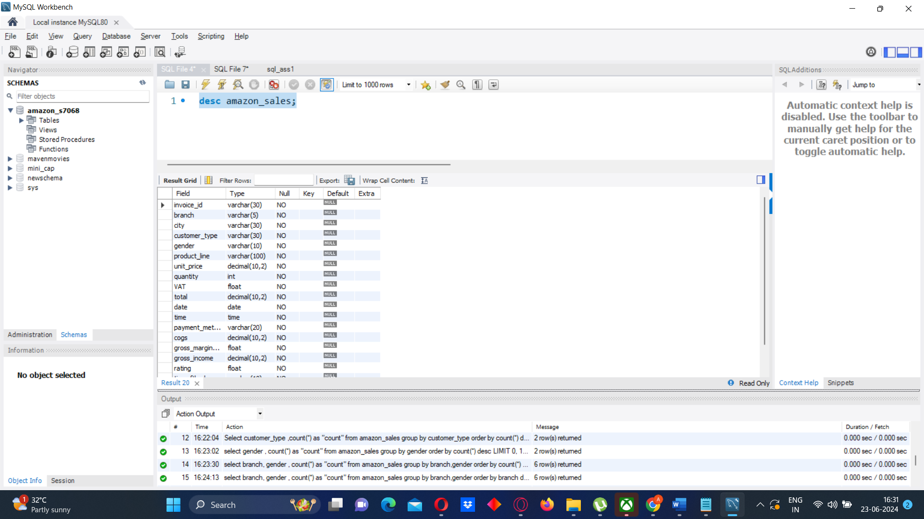

***#Loading .csv file data into amazon_sales table***

LOAD DATA INFILE 'file_path/Amazon.csv'

INTO TABLE amazon_sales

FIELDS TERMINATED BY ','

ENCLOSED BY '"'

LINES TERMINATED BY '\n'

IGNORE 1 ROWS;

Select * from amazon_sales;

Alter table amazon_sales add column (timeoftheday varchar(10) NOT NULL,dayname varchar(10) aNOT NULL , monthname varchar(10) NOT NULL);

Desc amazon_sales;



SET SQL_SAFE_UPDATES = 0;

Update amazon_sales

set timeoftheday = case

when substr(time,1,2) in (00,01,02,03,04,05,06,07,08,09,10,11) then "Morning"

when substr(time,1,2) in (12,13,14,15) then "Afternoon"

else "Evening"

end;

Update amazon_sales

set dayname = dayname(date),

monthname = monthname(date);

COMMIT;

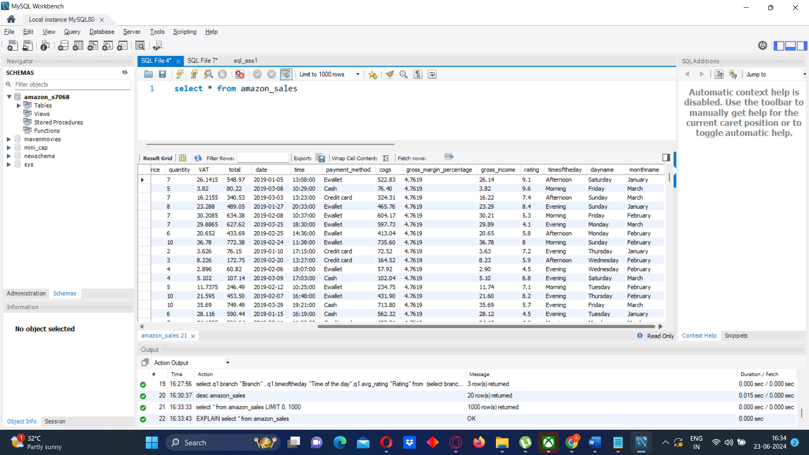

***#Data Analysis***

***#What is the count of distinct cities in the dataset?***

select count(distinct city) as count_of_city

from amazon_sales;

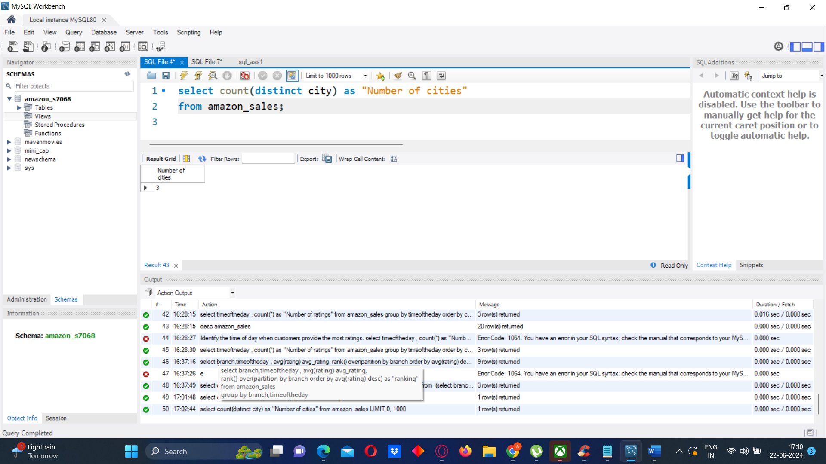

***#For each branch, what is the corresponding city?***

select city,branch

from amazon_sales

group by city,branch;

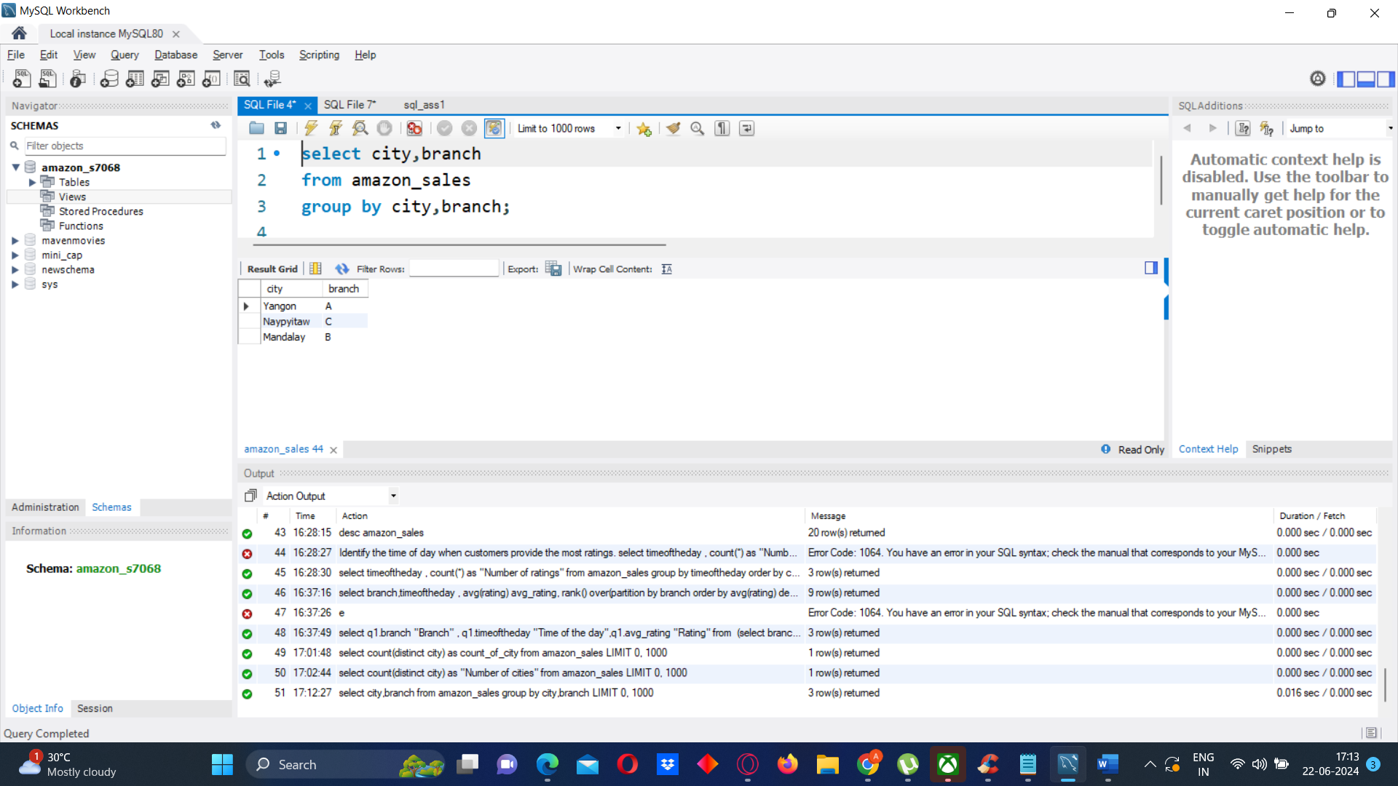

***#What is the count of distinct product lines in the dataset?***

select count(distinct product_line) as count_of_product_line

from amazon_sales;

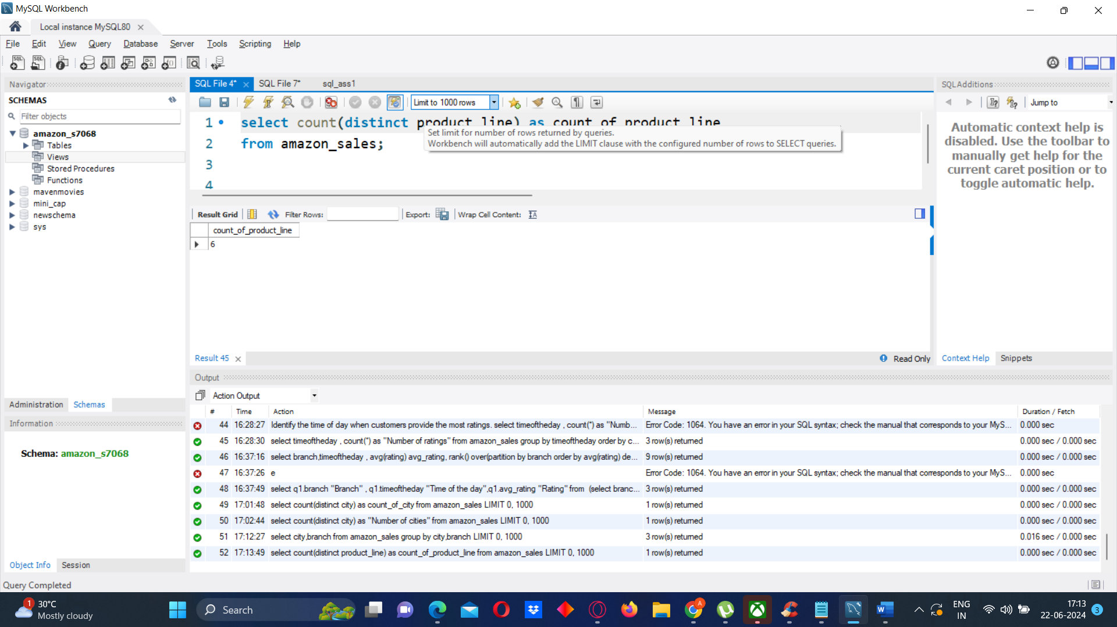

***#Which payment method occurs most frequently?***

select payment_method, count(*)

from amazon_sales

group by payment_method

order by count(*) desc;

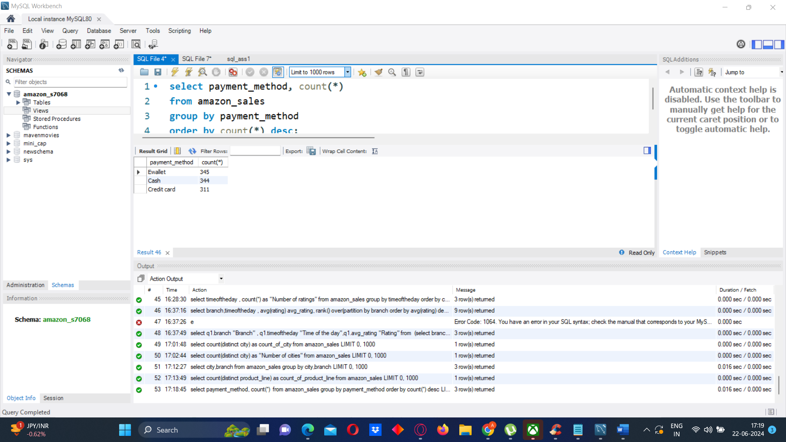

***#Which product line has the highest sales?***

Select product_line , sum(total) as "Highest sales"

from amazon_sales

group by product_line

order by sum(total) desc;

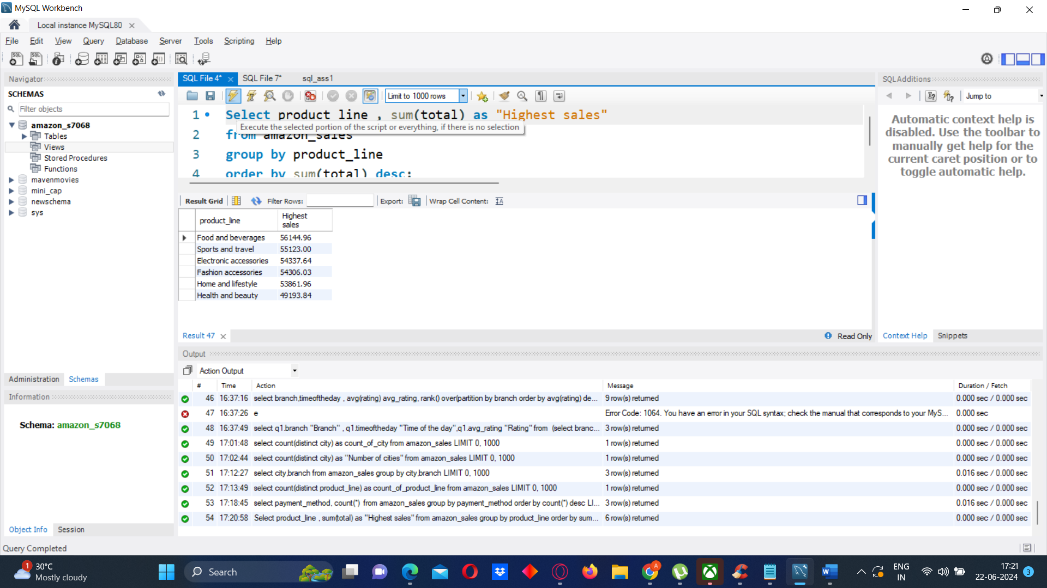

***#How much revenue is generated each month***

select monthname as "Month", sum(unit_price*quantity) as "Total_revenue"

from amazon_sales

group by monthname;

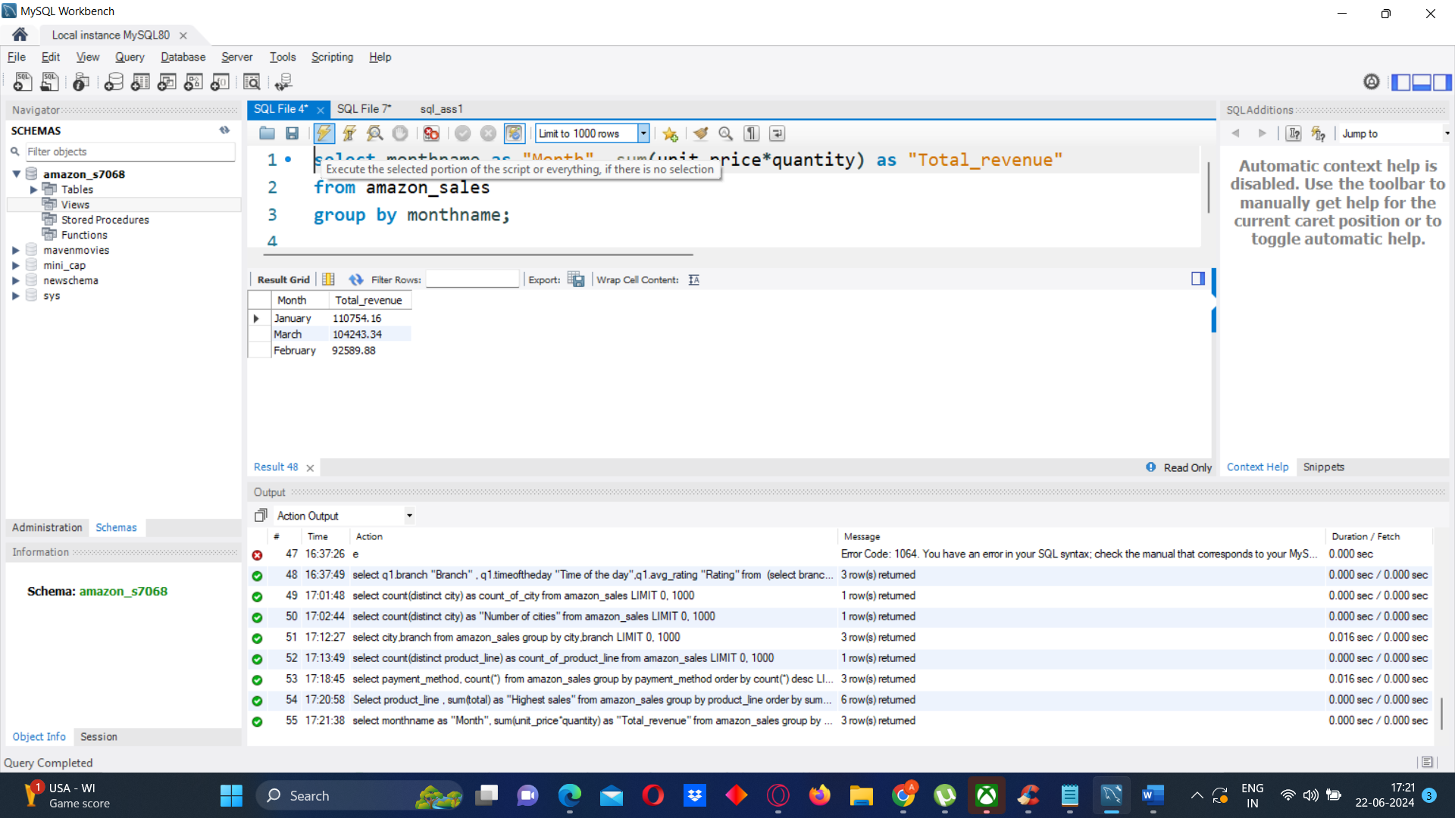

***#In which month did the cost of goods sold reach its peak?***

select monthname,sum(cogs) cost_of_goods_sold

from amazon_sales

group by monthname

order by sum(cogs) desc;

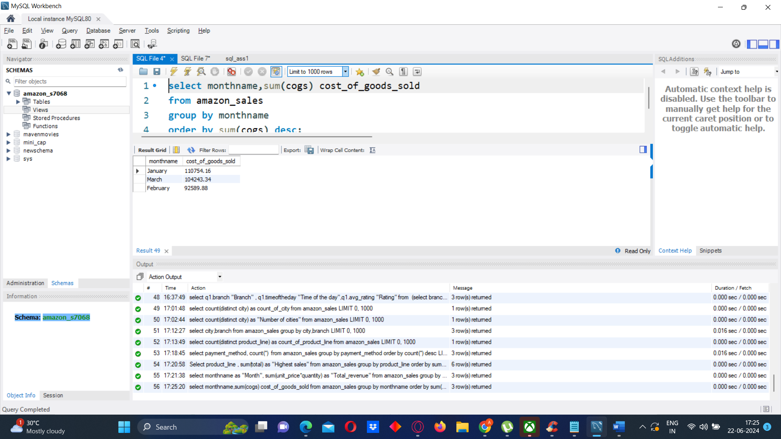

***#Which product line generated the highest revenue?***

select q1.product_line "Product Line with highest revenue", q1.revenue "Revenue generated"

from

(select product_line ,sum(unit_price*quantity) "revenue",

rank() over(order by sum(unit_price*quantity) desc) as "ranking"

from amazon_sales

group by product_line) q1

where q1.ranking = 1;

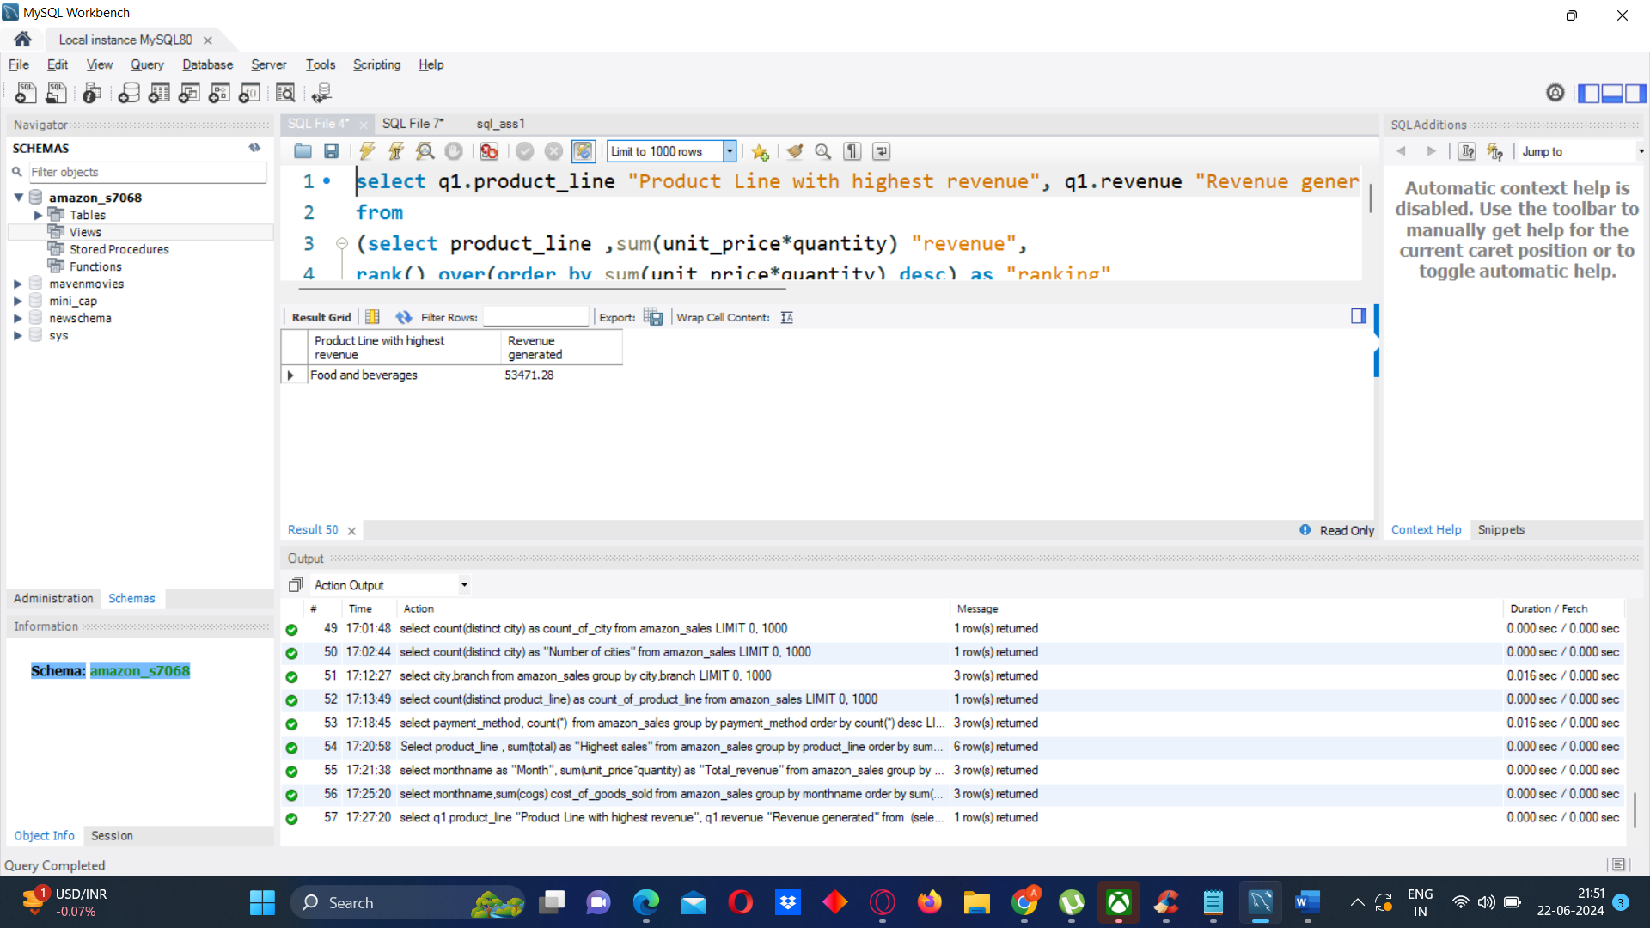

***#In which city was the highest revenue recorded?***

select q1.city as "City with highest revenue", q1.revenue "Revenue generated"

from

(select city ,sum(unit_price*quantity) "revenue",

rank() over(order by sum(unit_price*quantity) desc) as "ranking"

from amazon_sales

group by city) q1

where q1.ranking = 1;

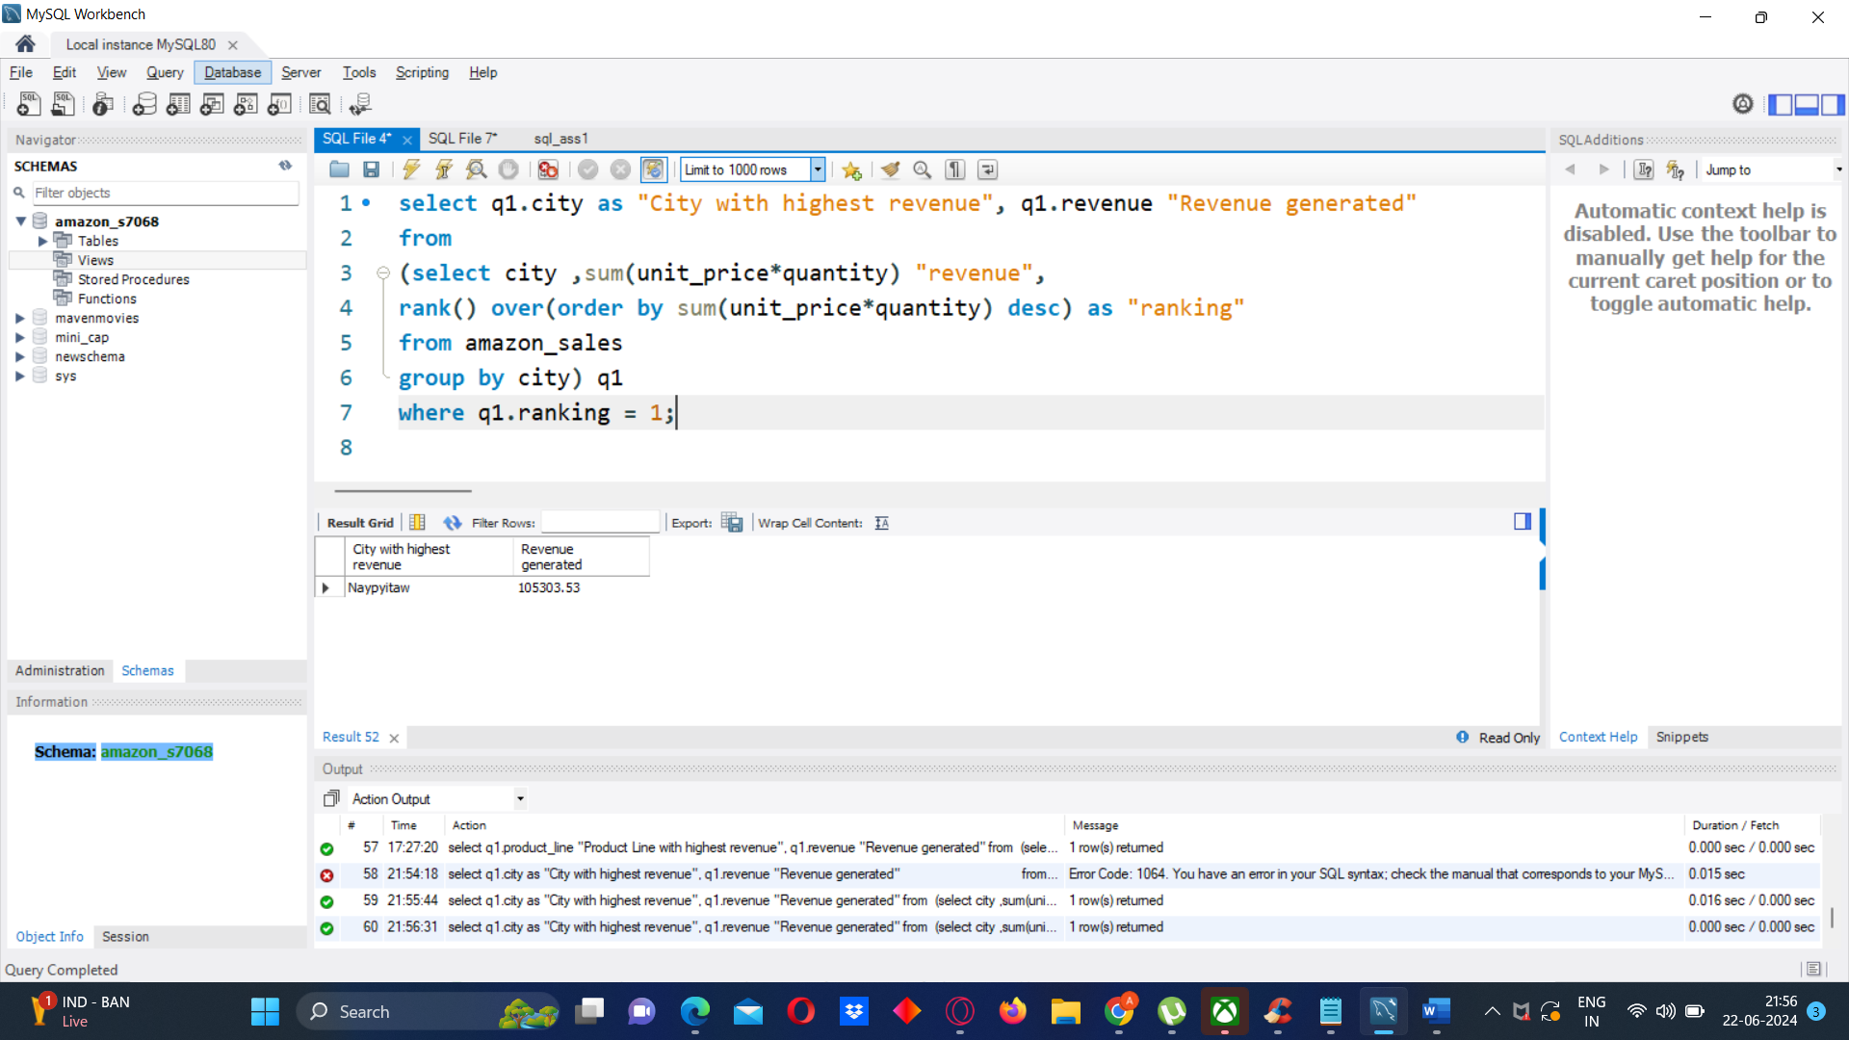

***#Which product line incurred the highest Value Added Tax?***

select q1.product_line "Product Line that incurred the highest VAT", q1.Total_VAT "VAT incurred"

from

(select product_line ,sum(VAT) "Total_VAT",

rank() over(order by sum(VAT) desc) as "ranking"

from amazon_sales

group by product_line) q1

where q1.ranking = 1;

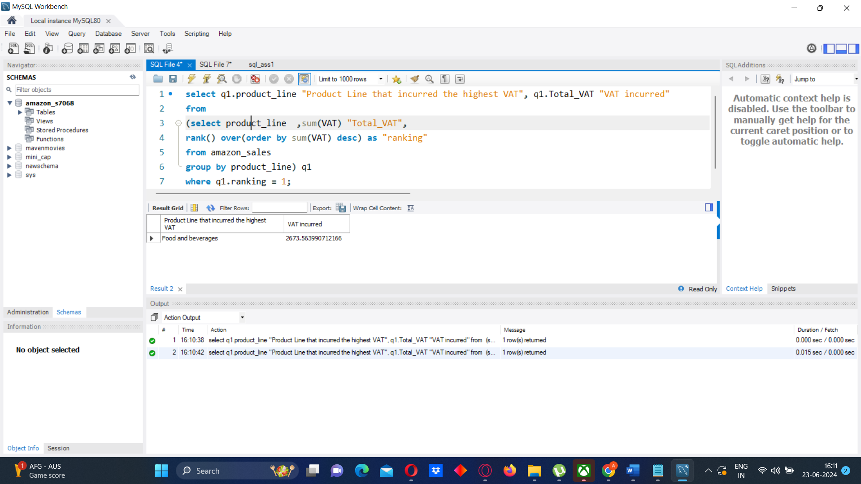

***#Calculate the average rating for each product line***

select product_line "Product line", avg(rating) "Average Rating"

from amazon_sales

group by product_line;

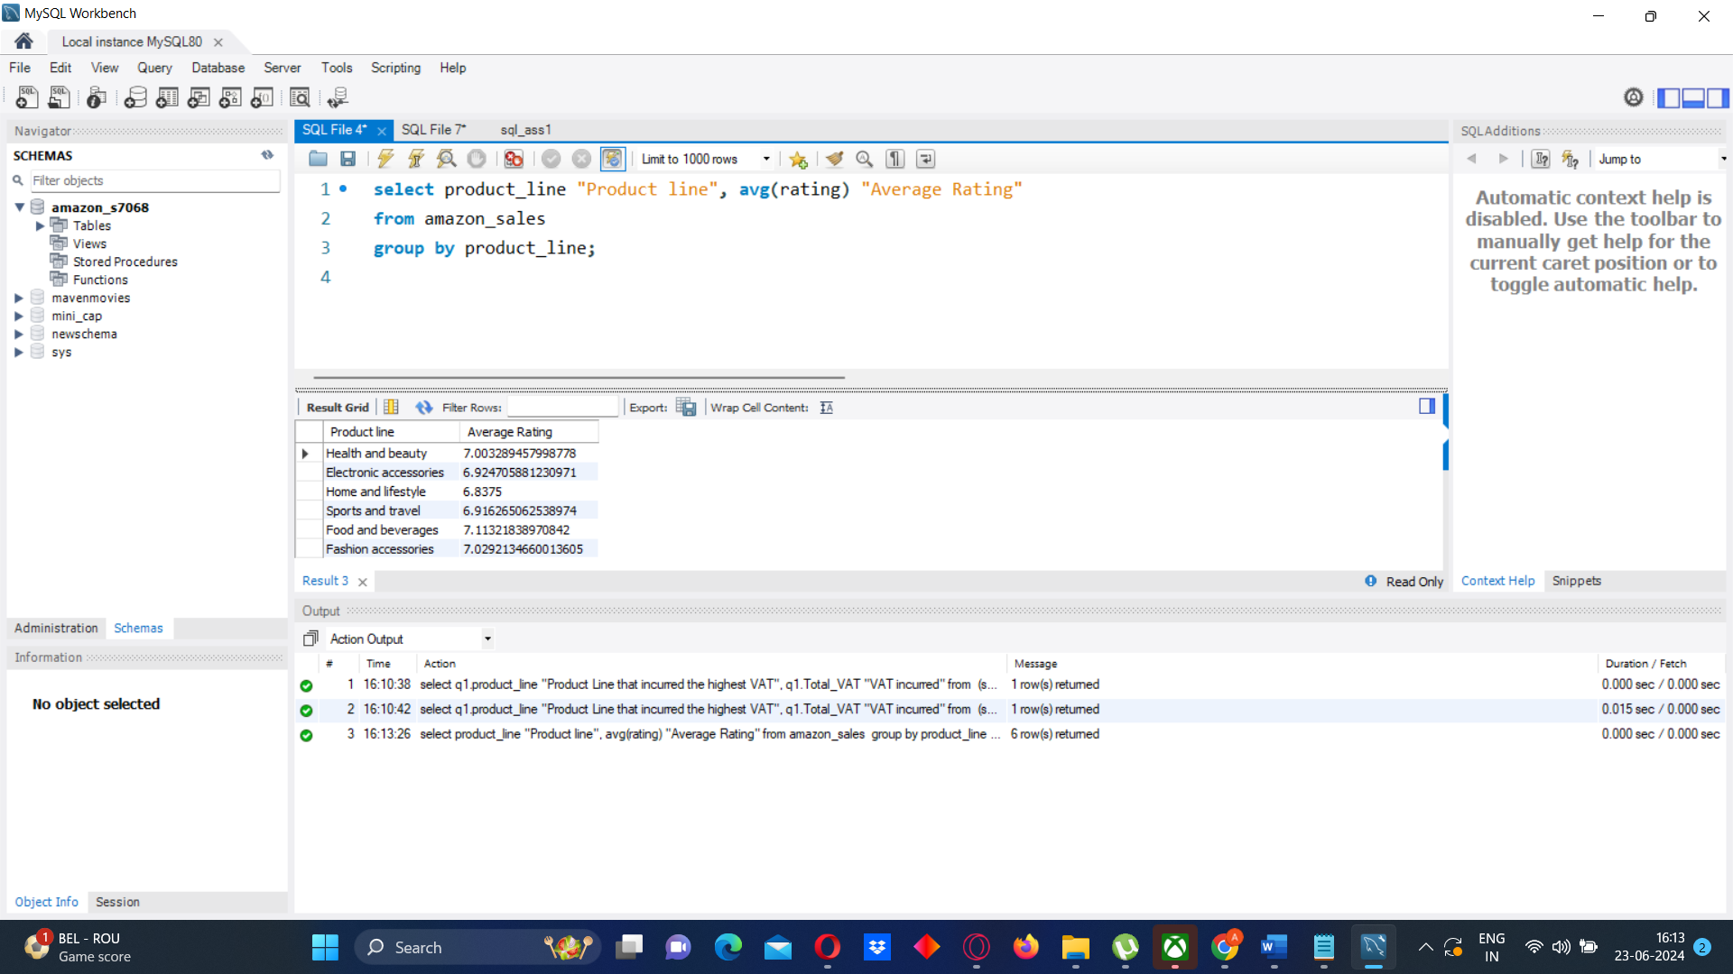

***#Count the sales occurrences for each time of day on every weekday.***

Select timeoftheday "Time of the day",count(*) "No. of Sales"

from amazon_sales

where dayname NOT IN ('Saturday','Sunday')

group by timeoftheday

order by count(*) desc;

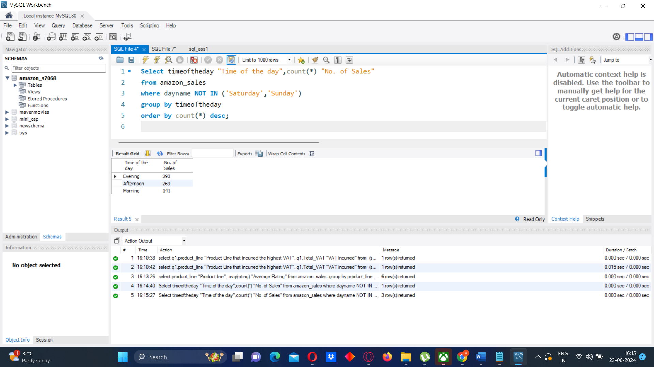

***#For each product line, add a column indicating "Good" if its sales are above average, otherwise "Bad."***

select product_line ,

case when sum(unit_price*quantity) > (select avg(unit_price*quantity)

from amazon_sales) then "Good"

else "Bad"

end as "grade"

from amazon_sales

group by product_line

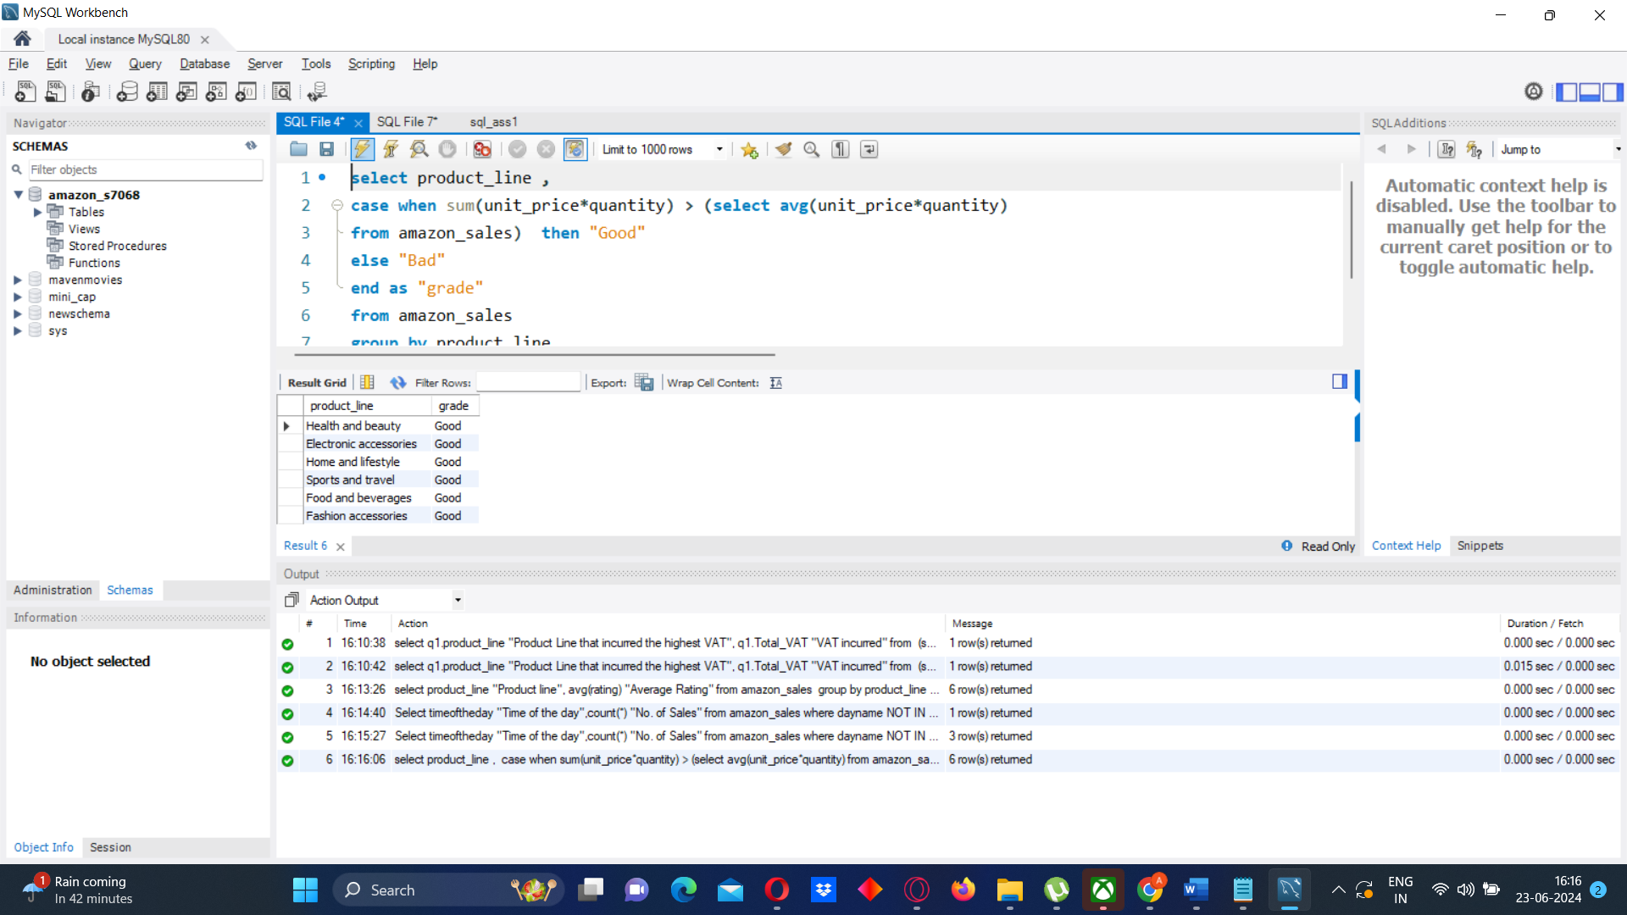

***#Customer type generating highest revenue***

select q1.customer_type as "Customer type generating highest revenue", q1.revenue "Revenue generated"

from

(select customer_type ,sum(unit_price*quantity) "revenue",

rank() over(order by sum(unit_price*quantity) desc) as "ranking"

from amazon_sales

group by customer_type) q1

where q1.ranking = 1;

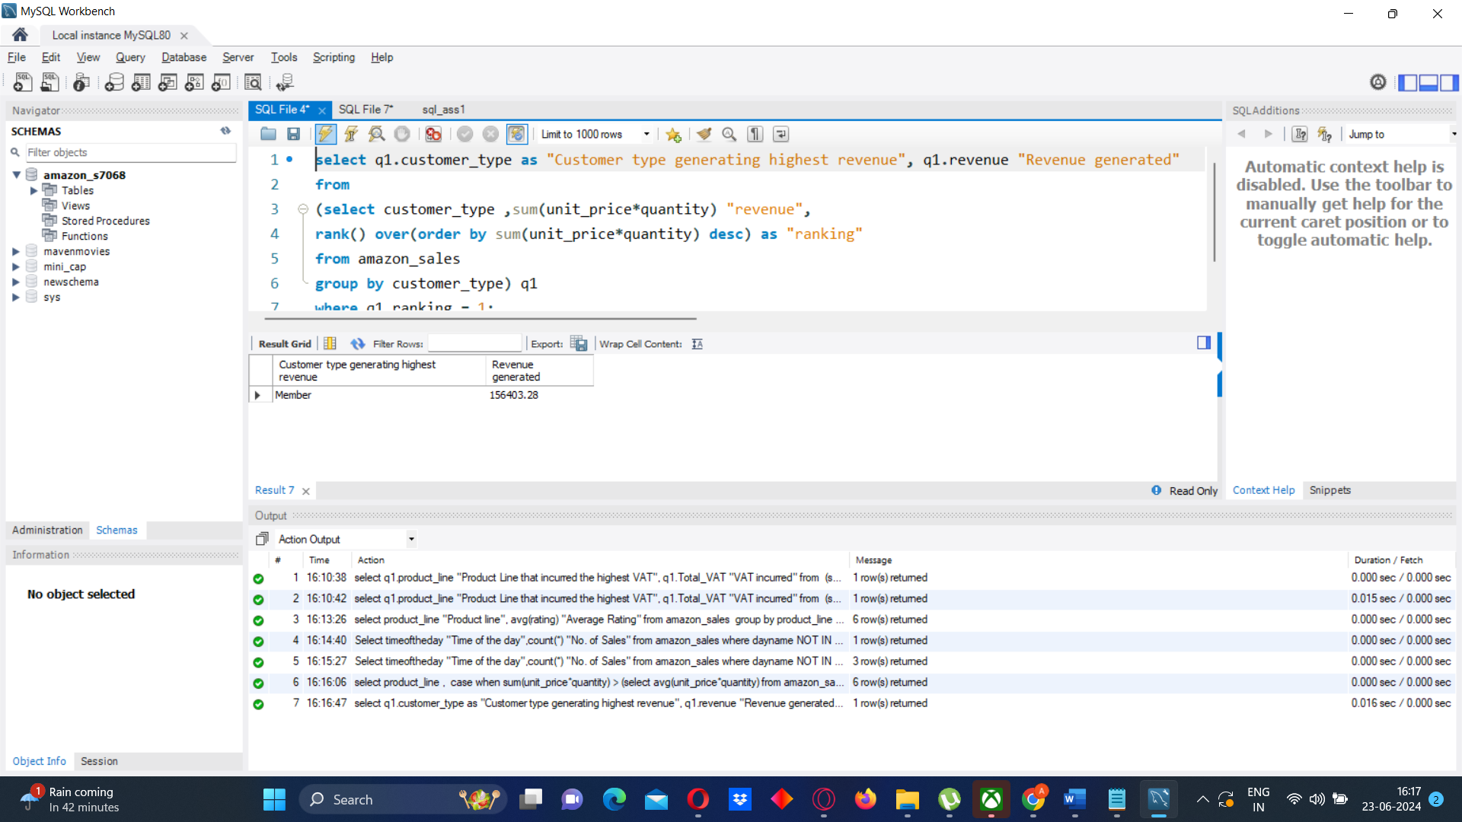

***#What is the count of distinct customer types in the dataset?***

select customer_type "Customer Type" , count(*) "No. of records"

from amazon_sales

group by customer_type

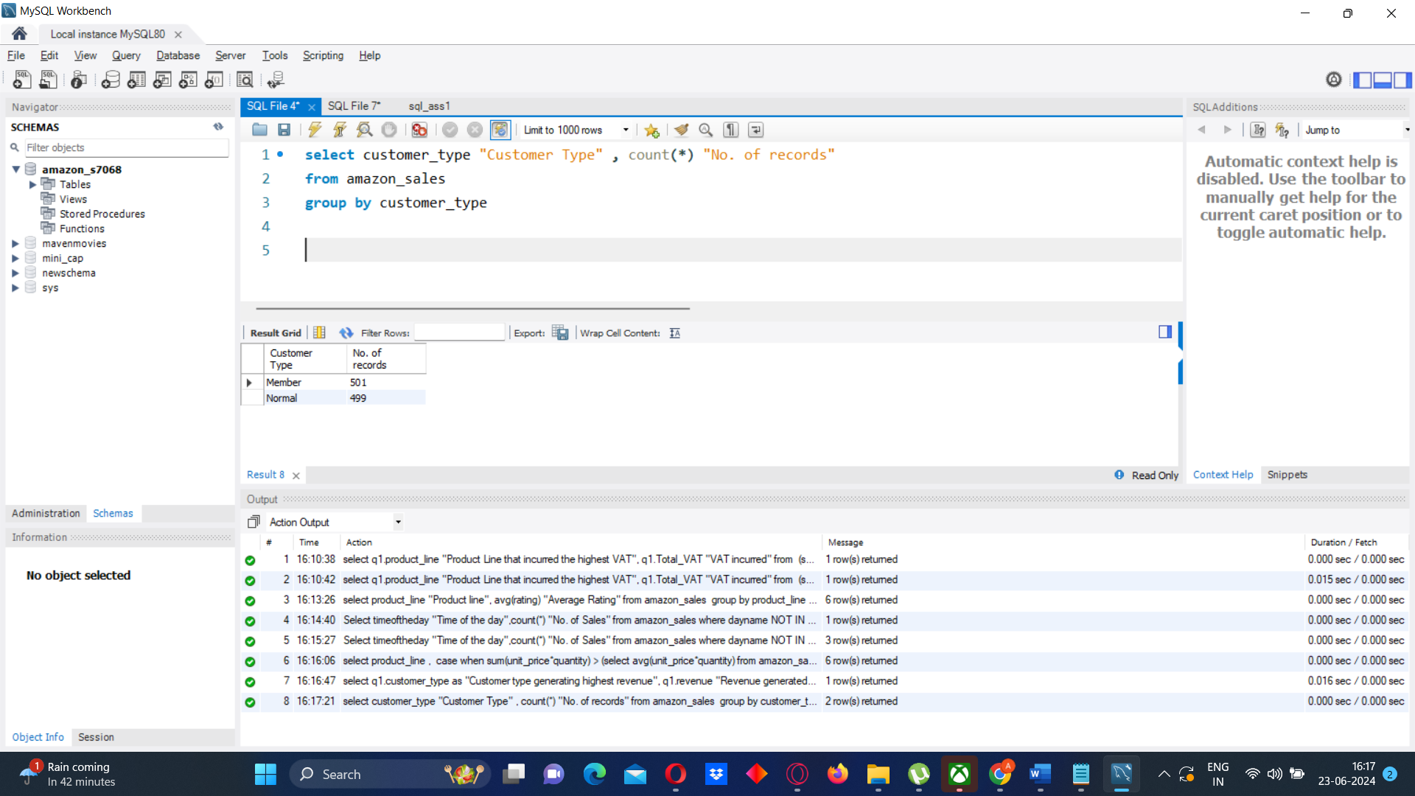

***#What is the count of distinct payment methods in the dataset?***

select payment_method "Payment Method" , count(*) "No. of records"

from amazon_sales

group by payment_method

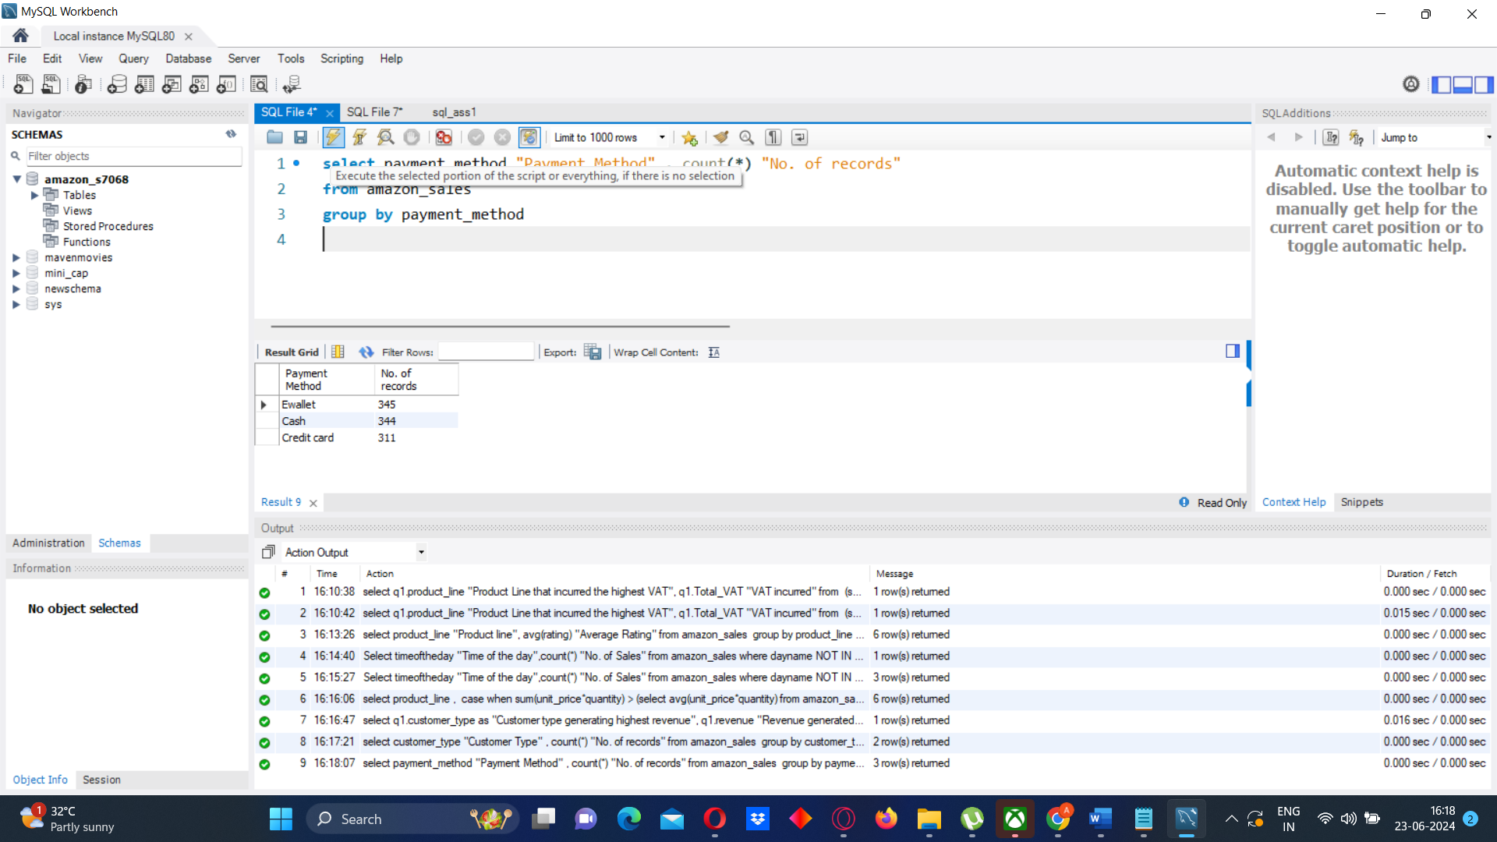

***#Determine the city with the highest VAT percentage.***

select city, round(AVG((VAT/total)*100),2) as "Average VAT Percentage", total

from amazon_sales

group by city

order by round(AVG((VAT/total)*100),2) desc

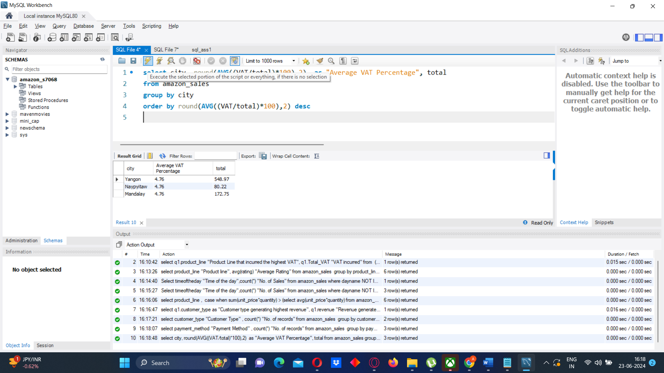

***#Identify the customer type with the highest VAT payments***

select customer_type "Customer Type" , sum(VAT) "VAT Payments"

from amazon_sales

group by customer_type

order by sum(VAT) desc

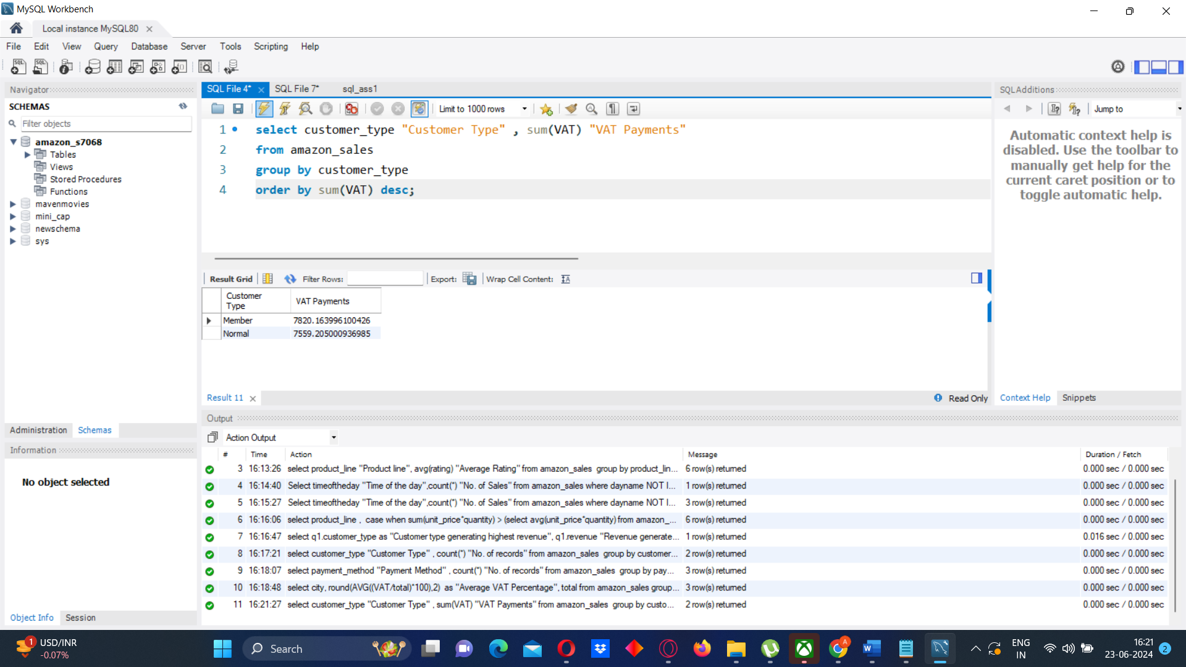

***#Which customer type occurs most frequently?***

Select customer_type ,count(*) as "count"

from amazon_sales

group by customer_type

order by count(*) desc

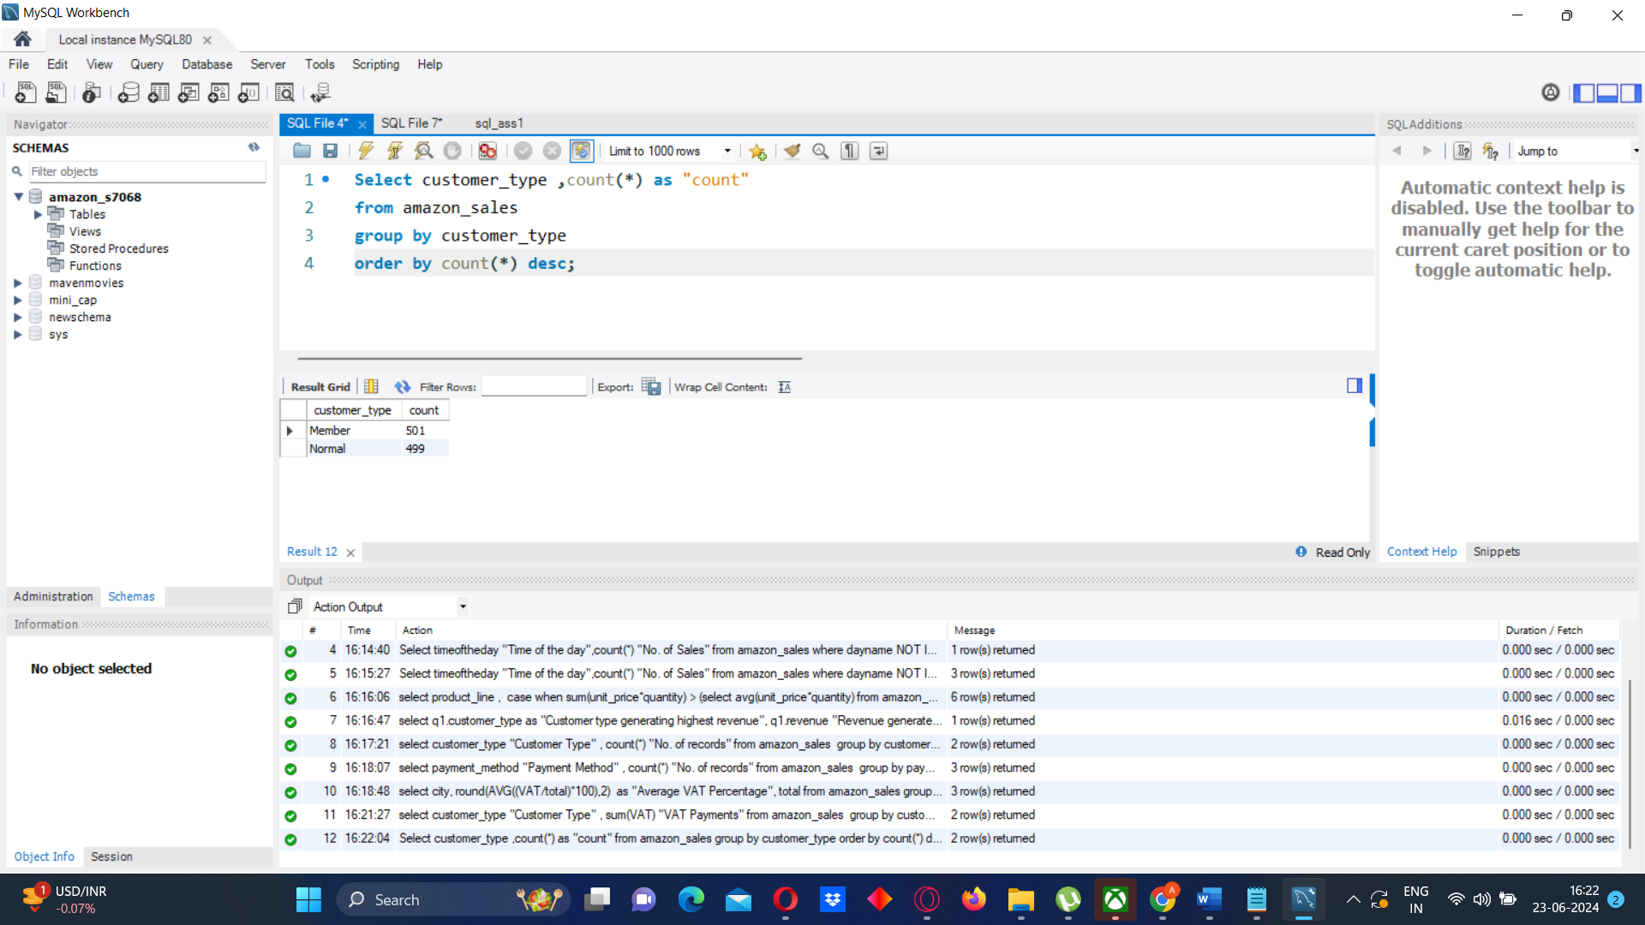

***#Determine the predominant gender among customers***

select gender , count(*) as "count"

from amazon_sales

group by gender

order by count(*) desc;

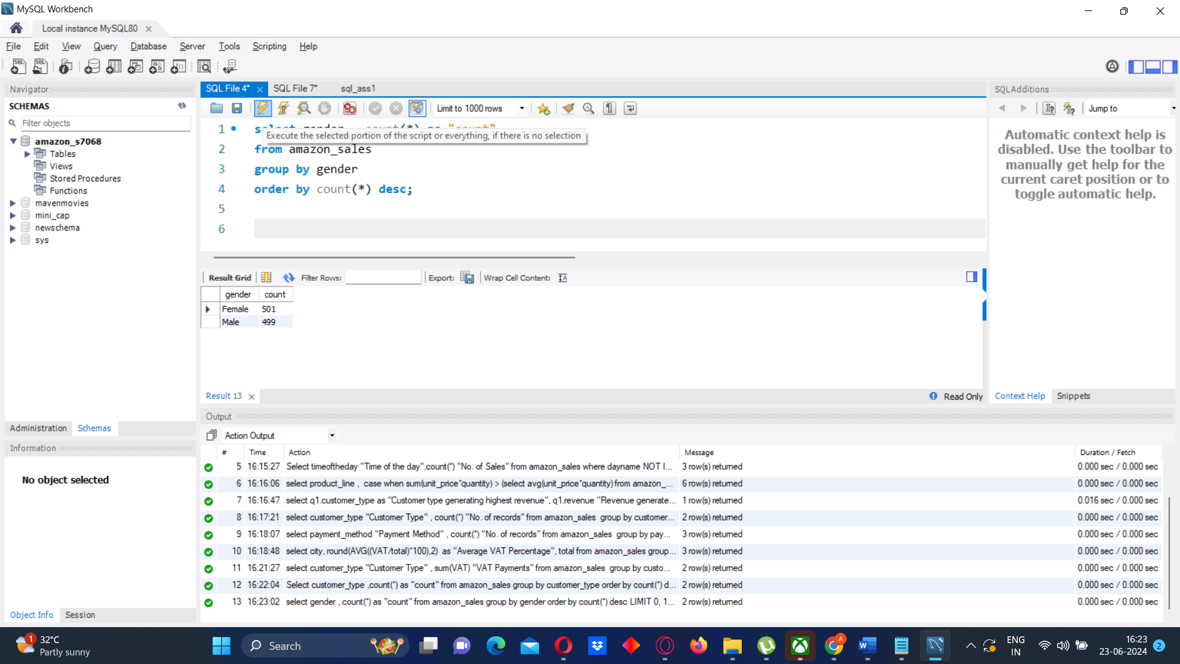

***#Examine the distribution of genders within each branch.***

select branch, gender , count(*) as "count"

from amazon_sales

group by branch,gender

order by branch;

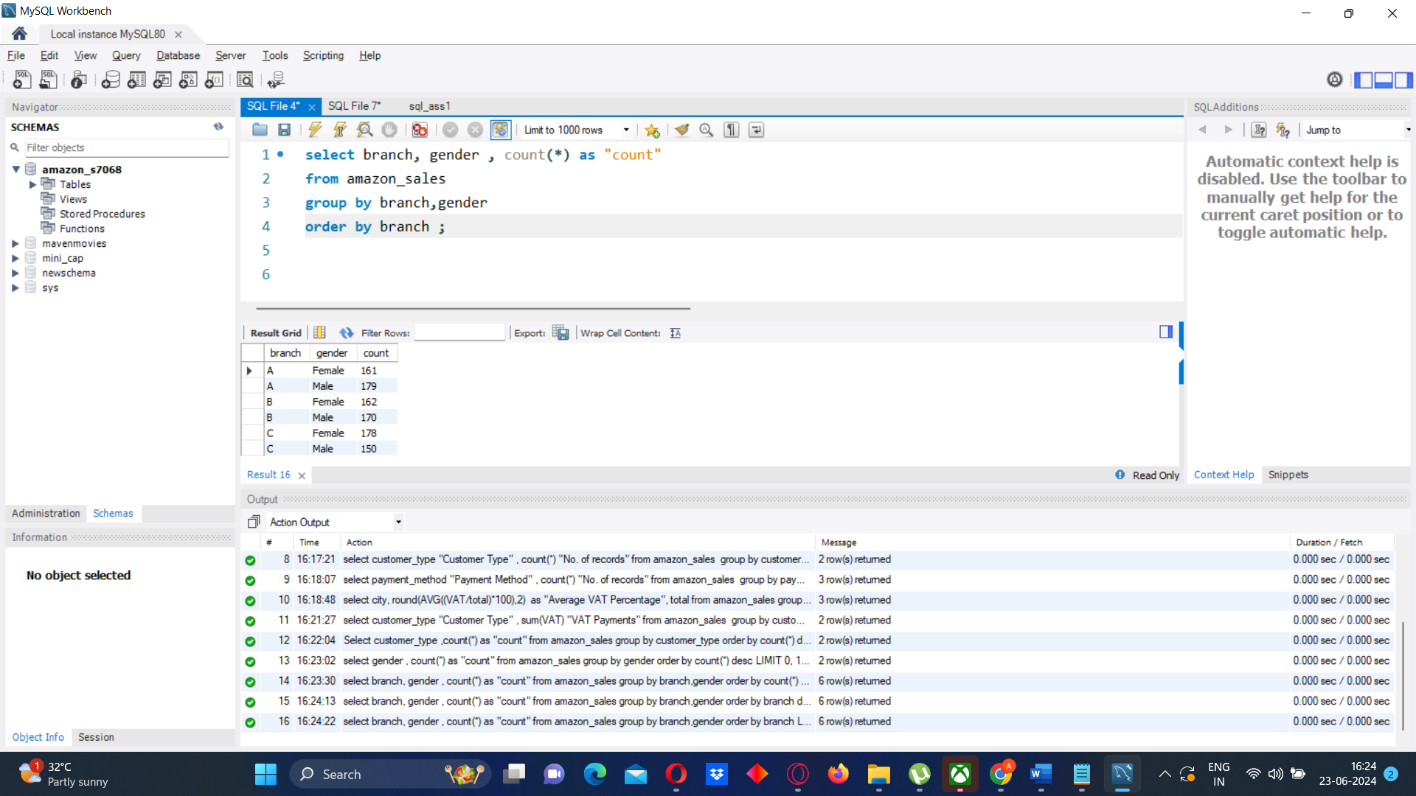

***#Determine the day of the week with the highest average ratings for each branch.***

select q1.branch "Branch" , q1.dayname "Day of the week",q1.avg_rating "Rating"

from

(select branch,dayname , avg(rating) avg_rating,

rank() over(partition by branch order by avg(rating) desc) as "ranking"

from amazon_sales

group by branch,dayname) q1

where q1.ranking = 1;

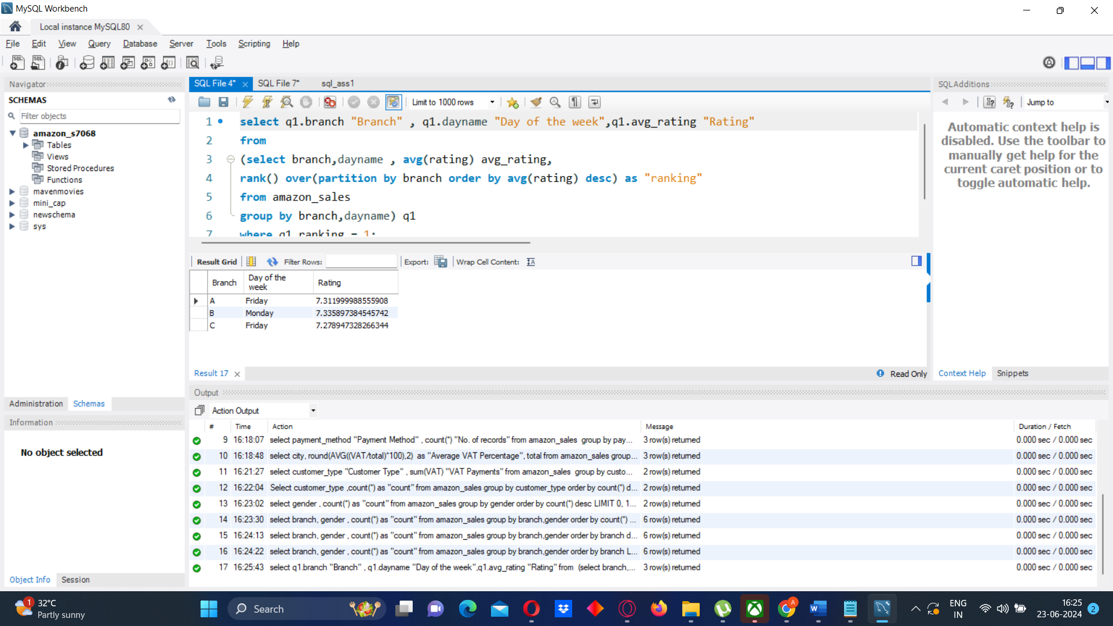

***#Identify the time of day when customers provide the most ratings.***

select timeoftheday , count(*) as "Number of ratings"

from amazon_sales

group by timeoftheday

order by count(*) desc;

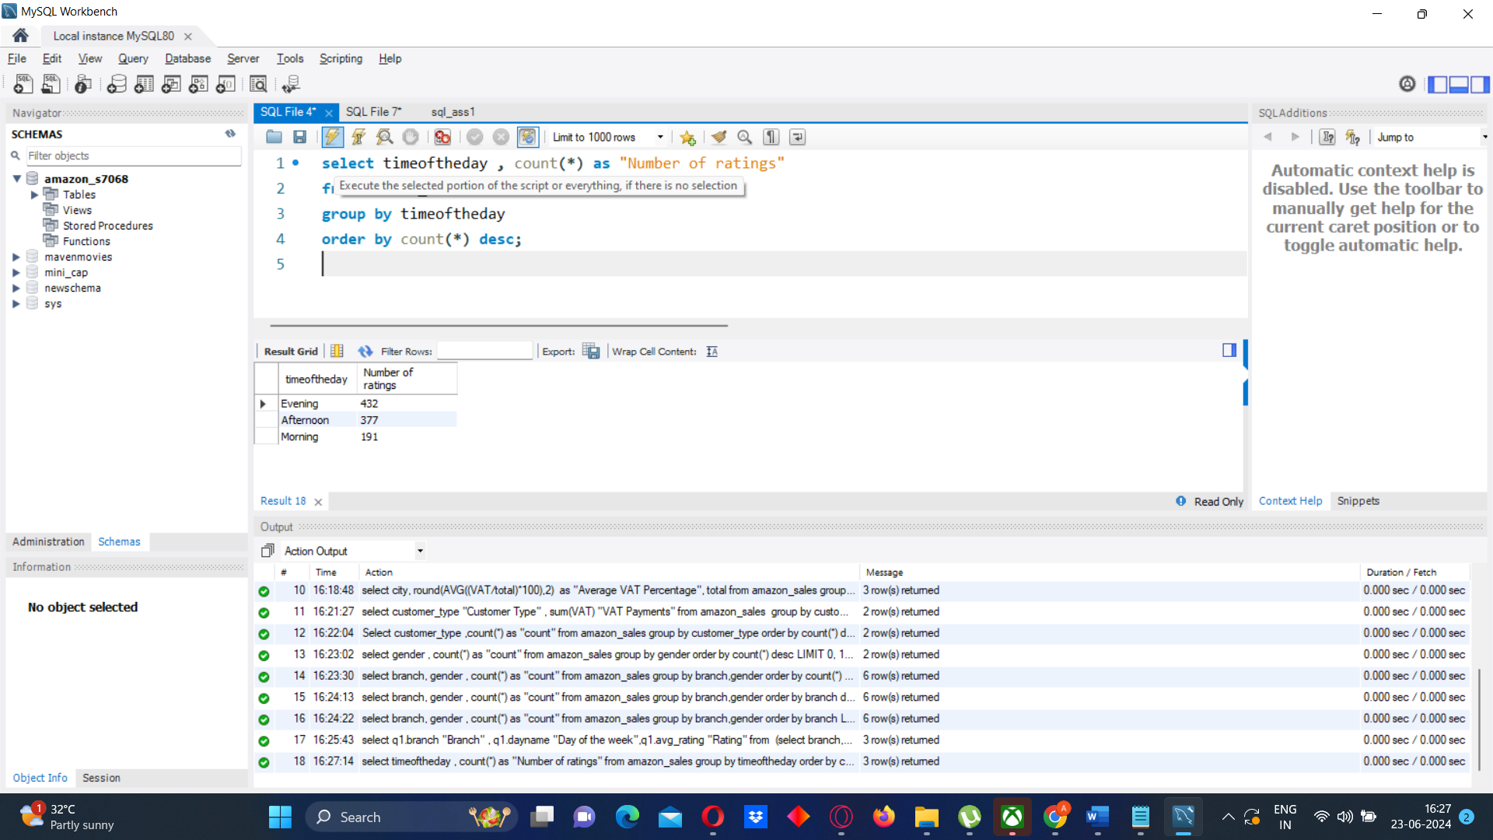

***#Determine the time of day with the highest customer ratings for each branch.***

select q1.branch "Branch" , q1.timeoftheday "Time of the day",q1.avg_rating "Rating"

from

(select branch,timeoftheday , avg(rating) avg_rating,

rank() over(partition by branch order by avg(rating) desc) as "ranking"

from amazon_sales

group by branch,timeoftheday) q1

where q1.ranking = 1;

